MGT 40750 – Quantitative Decision Modeling Spring 2017

**Exercises for the Midterm Exam**

Questions 1, 2, 3, and 4 are based on the manufacturing problem described by the following process flow map:

Buffer

Raw Materials

Work Station

Production

Work Station

Quality Inspection

Decision Point

DP

Buffer

Finished Goods

Buffer

Rework Line for Defective Goods

Work Station

Rework

Buffer

Reworked Goods

We let time units denote minutes. Suppose the working time at Production can be approximated by a normal distribution with a mean of 5 minutes and a standard deviation of 1 minute. The working time at Quality Inspection can be approximated by a normal distribution with a mean of 3 minutes and a standard deviation of 1 minute. After completing the quality inspection, 5% of the products are identified as defective goods and need rework. The rest are considered finished goods. Defective goods are put in a storage area to wait for rework. The working time at Rework can be approximated by an exponential distribution with a mean of 5 minutes.

Run 50 simulations of this manufacturing process for an 8-hour working day. The initial number of raw materials is 200.

**Question 1:**

The following is a SimQuick model for the manufacturing problem. There are three errors in this set up. Circle the errors and correct them.



After fixing the errors in SimQuick, we get the following results:



**Question 2:**

This manufacturing process generates two types of goods: Finished Goods and Reworked Goods.

What’s the throughput for Finished Goods? _________

What’s the throughput for Reworked Goods? _________

**Question 3:**

In this manufacturing problem, the manufacturing process generates two types of goods: Finished Goods and Reworked Goods.

*(Hint: In calculating the mean cycle time of process, we don’t need to include the time spent in the first buffer “Raw Materials” or the last buffer “Finished Goods” / “Reworked Goods.”)*

What’s the mean cycle time of process for Finished Goods? _________ minutes

What’s the mean cycle time of process for Reworked Goods? _________ minutes

What’s the utilization of the Rework work station? _________ percent

**Question 4:**

In this manufacturing problem, we want to conduct sensitivity analysis to test the impact of varying working time at Rework (consider five scenarios with exponential distribution with a mean of 5, 10, 15, 20, and 25 minutes) on the waiting time at the Rework Line.

*(Hint: To save time, you don’t have to use the computer to solve this problem.)*

Revise the setup of work station Rework using ScenVar(∙) and specify Scenarios below:

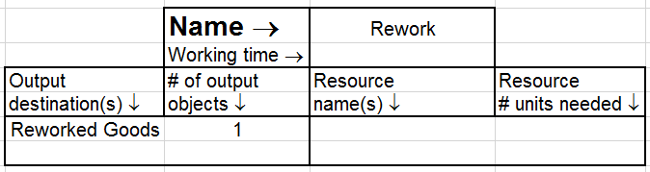

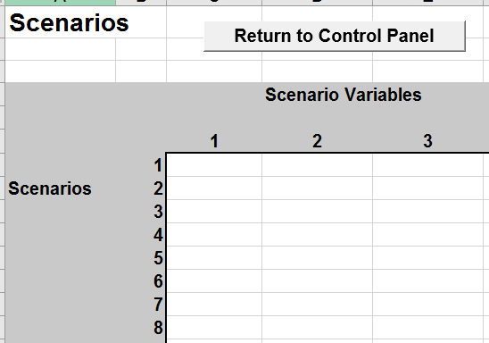

**Question 5:**

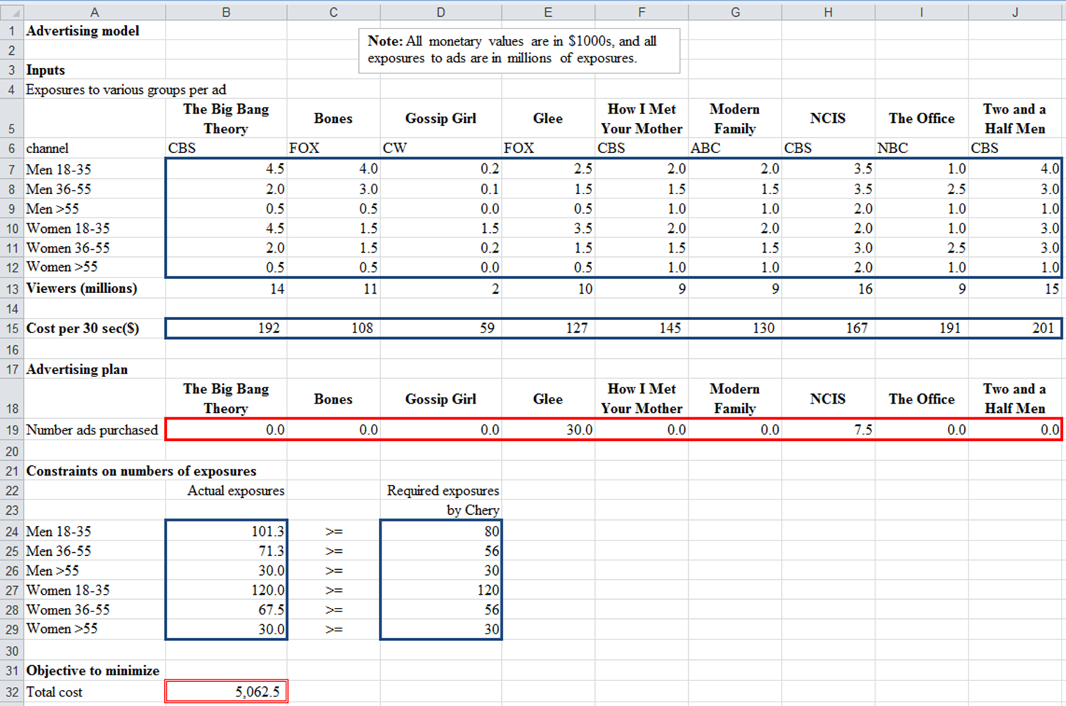Recall the Chery advertising example we discussed in class. The linear solution is presented below.

*(Hint: To save time, you don’t have to use the computer to solve this problem.)*

1. The optimal total cost would _________ (increase / decrease / remain unchanged) if cost per 30-second ads for all shows increase by 10%.
2. The optimal total cost would _________ (increase / decrease / remain unchanged) if Chery requires 150 million exposures for the Women 18-35 group.
3. The optimal total cost would _________ (increase / decrease / remain unchanged) if Chery requires 100 million exposures for the Men 18-35 group.
4. The optimal total cost would _________ (increase / decrease / remain unchanged) if Chery cannot advertise on CBS.

Questions 6 and 7 are based on the furniture production problem described below.

A furniture company manufactures tables and chairs. A table requires 40 board feet of wood, and a chair requires 30 board feet of wood. Wood can be purchased at a cost of $1.50 per board foot, and 40,000 board feet of wood are available for purchase. It takes two hours of skilled labor to manufacture an unfinished table or an unfinished chair. Three more hours of skilled labor will turn an unfinished table into a finished table, and two more hours of skilled labor will turn an unfinished chair into a finished chair. A total of 5,000 hours of skilled labor is available (and *have already been paid for*). All furniture produced can be sold at the following unit prices: an unfinished table, $130; a finished table $220; an unfinished chair, $80; a finished chair, $175.

**Question 6:**

We would like to determine how to maximize the company’s profit from manufacturing tables and chairs. The following is an incomplete Excel worksheet for this problem.

Suppose our decision variables are B17:C17, B19:C19.

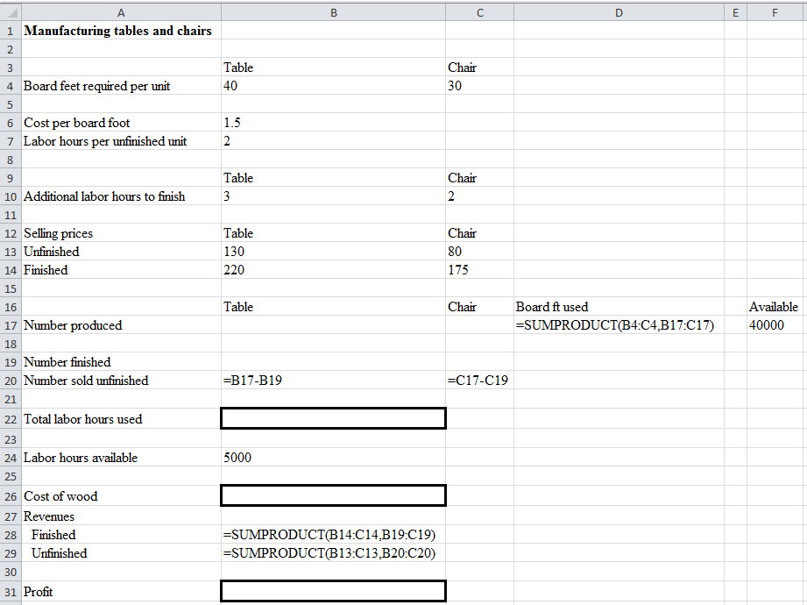

Specify the formulas for the following three cells:

Formula for B22: ______________________________________________________________________

Formula for B26: ______________________________________________________________________

Formula for B31: ______________________________________________________________________

**Question 7:**

Complete the Solver setup below (only need to specify the constraints):

Set Objective: B31

To: Max

By Changing Variable Cells: B17:C17,B19:C19

Subject to the Constraints:

|  |
| --- |
|  |

X Make Unconstrained Variables Non-Negative

Select a Solving Method: Simplex LP

Report the optimal solution below:

|  |  |  |
| --- | --- | --- |
|  | Table | Chair |
| Number produced |  |  |
| Number finished |  |  |

Report the optimal profit below:

Profit = ___________________